**Year 4**

**Revision Unit 12 – 13**

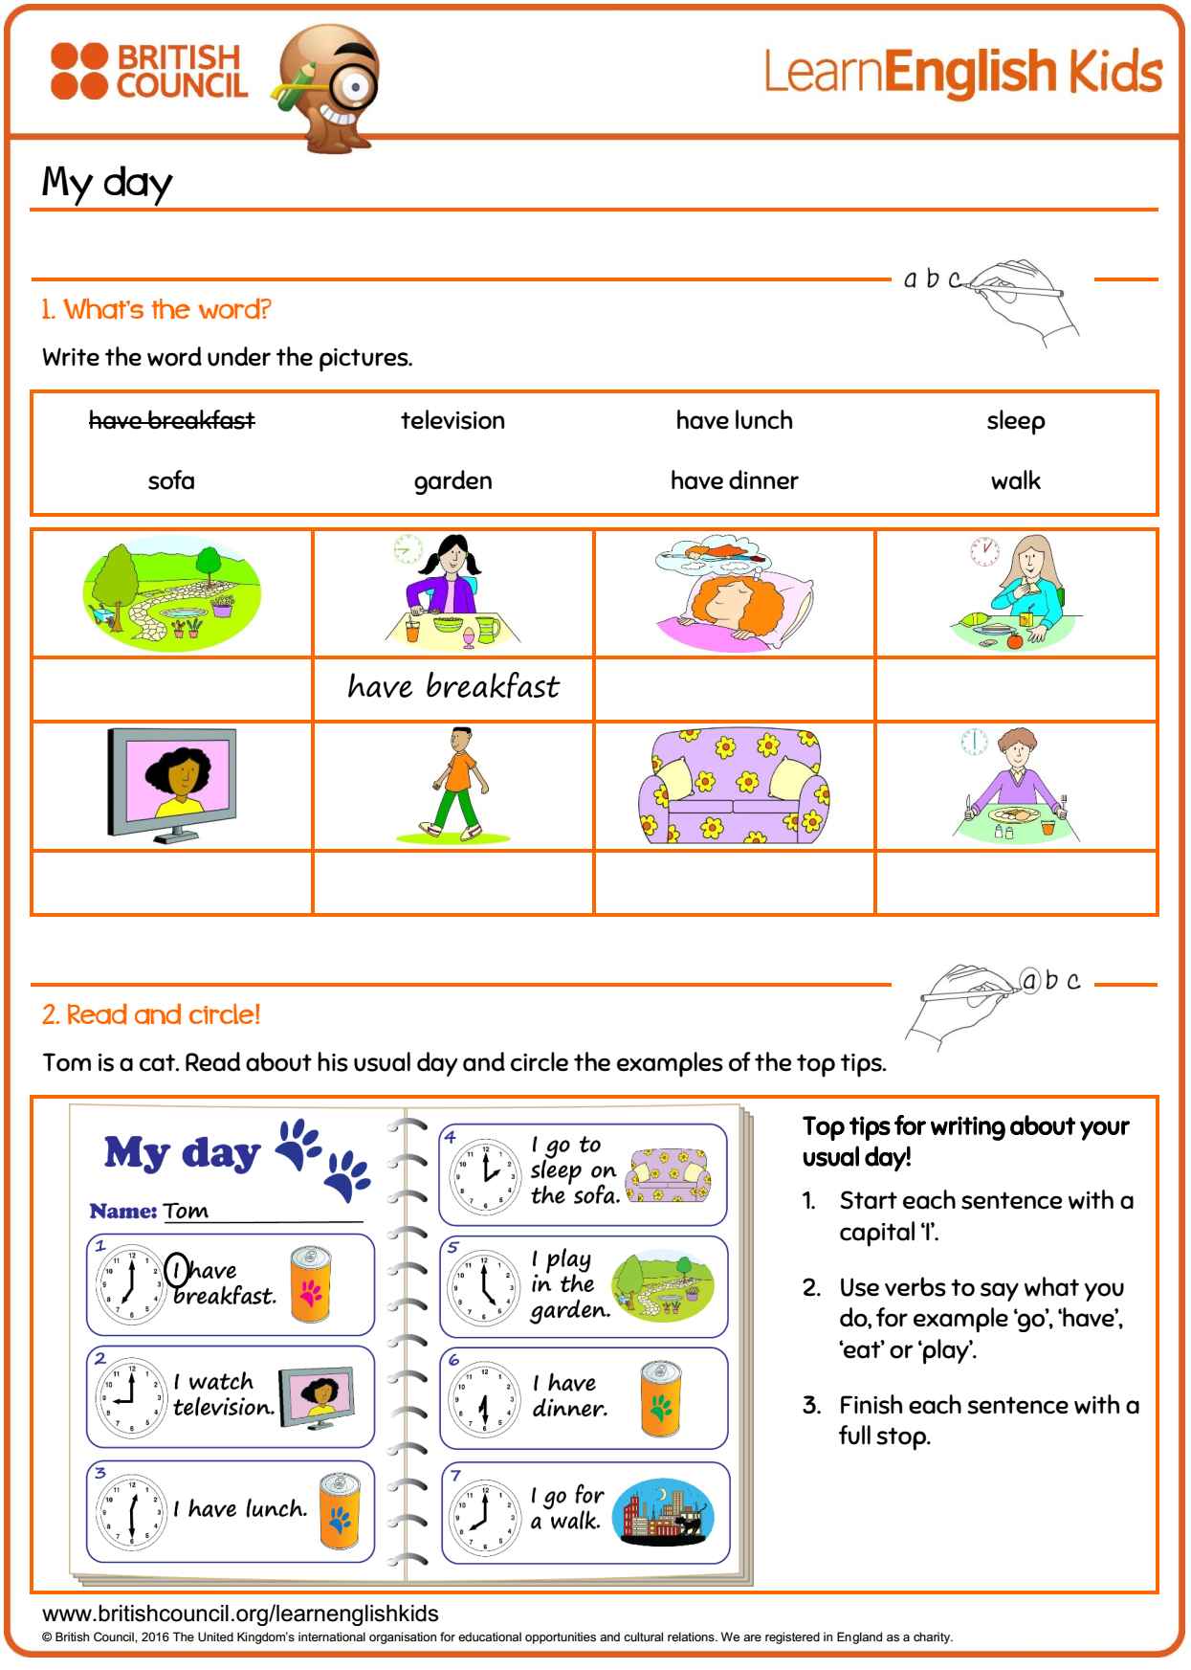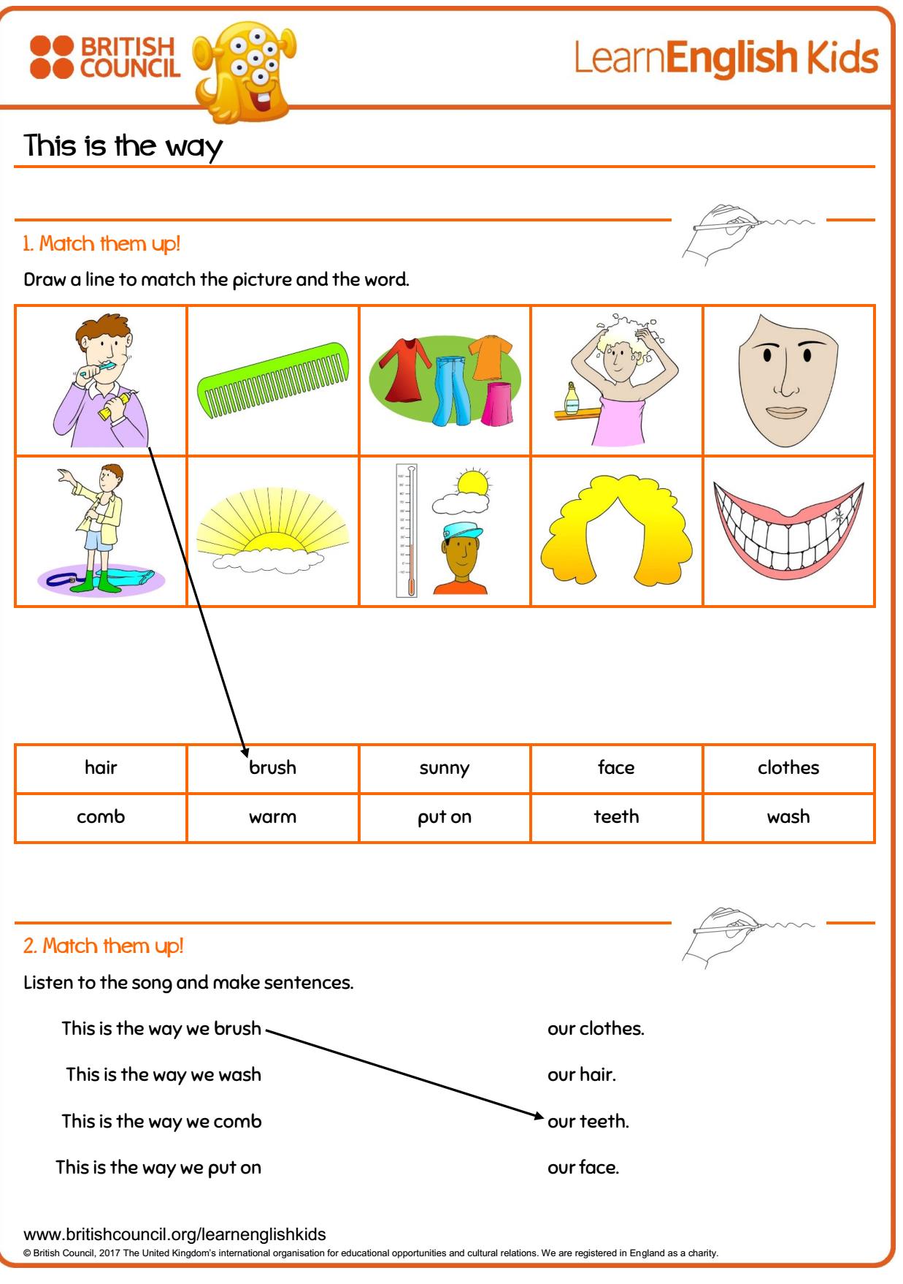

Name: ______________________________________________ Date:________________________