**Adjectives**

**Comparative and Superlative**

Comparative than **er**  to the adjective (more)

Superlative the   **est** to the adjective (the most)

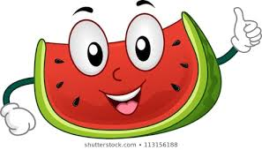

1. Maria is taller than Chris (tall).
2. Melons are sweeter than oranges (sweet).
3. This is the most interesting book of all my books (interesting).
4. Summer is hotter than spring (hot).
5. My car is faster than yours. George’s car is the fastest of all (fast).
6. My bag is heavier than Anna’s bag (heavy).
7. Why are you sad? Because I got the lowest grade of all the kids in my class (low).
8. Your red skirt is shorter than your yellow one (short).

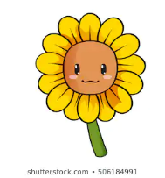

1. Andreas is the tallest boy in my class (tall).
2. In my opinion, roses are more beautiful than sunflowers (beautiful).
3. England is bigger country than Cyprus (big).
4. North Pole is the coldest place on Earth (cold).
5. Tonight, I hope to see a happier dream than last night (happy).
6. Andria has the longest hair of all the girls in her class (long).