**Adjectives**

**Comparative and Superlative**

Comparative than **er**  to the adjective (more)

Superlative the   **est** to the adjective (the most)

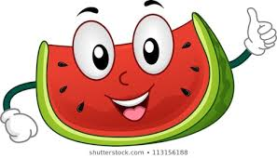

1. Maria is …………………… than Chris (tall).
2. Melons are …………………… than oranges (sweet).
3. This is the …………………………………………………. book of all my books (interesting).
4. Summer is ……………….than spring (hot).
5. My car is ……………………… than yours. George’s car is the ………………. of all (fast).
6. My bag is ………………. than Anna’s bag (heavy).
7. Why are you sad? Because I got the ………………. grade of all the kids in my class (low).
8. Your red skirt is ……………….than your yellow one (short).

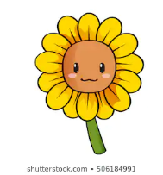

1. Andreas is the …………………. boy in my class (tall).
2. In my opinion, roses are …………………………………….. than sunflowers (beautiful).
3. England is ………………. country than Cyprus (big).
4. North Pole is the ………………………… place on Earth (cold).
5. Tonight, I hope to see a ……………………….. dream than last night (happy).
6. Andria has the ……………………… hair of all the girls in her class (long).