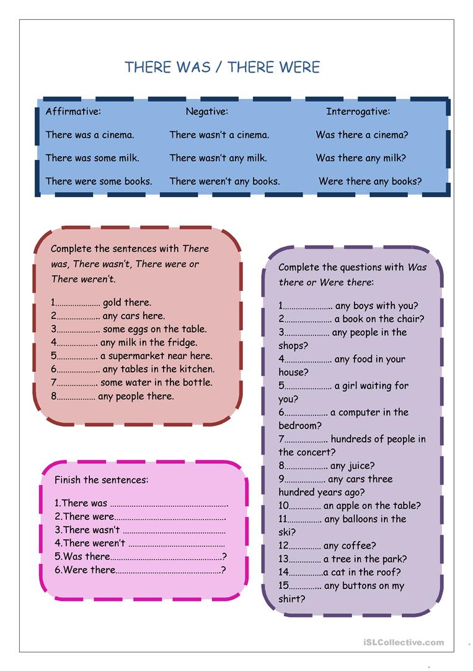

**Interrogative:**

Was there a bird on the tree?

Was there any milk in the fridge?

Were there two students in the bus?

Were there any books on the shelf?

**Negative**

There wasn’t a bird on the tree.

There wasn’t any milk in the fridge.

There weren’t two students in the bus.

There weren’t any books on the shelf

**There was/there were**

**Affirmative:**

There was a bird on the tree.

There was some milk in the fridge.

There were two students in the bus.

There were some books on the shelf.